Document Based Database
25th May 2025 R00225669 Rebecca Lordan
MongoDB
Part 1 – MongoDB CRUD
1.Create a new database “banksdb” and new collection “clients” Manually insert all documents in the json file into this collection. List out all collections in your database and documents to confirm that you have all documents in the correct collection. Then insert the following client to your collection.

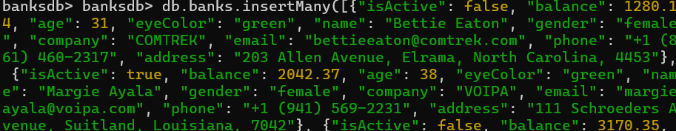
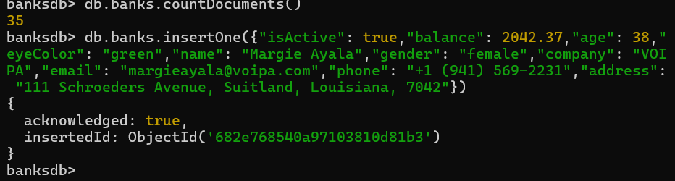
2. Explain why the profile of Margie has been inserted twice? How do we fix this problem? What happens if we try to reinsert the same profile of Margie again after you fixed the problem?
Margie Ayala was in the database twice because MongoDB doesn’t stop duplicated documents by default. When Margie’s information was entered twice with different ids, MongoDB didn’t catch that it was the same person. To make sure any duplicates don’t occur by making the email unique, MongoDB won’t allow a person to be added it they share the same email.
If we try to add Margie’s profile again after fixing the problem, MongoDB will show an error and it won’t allow the duplicate to be added. This is good as it gets ride of having the Margie in the database more than once.
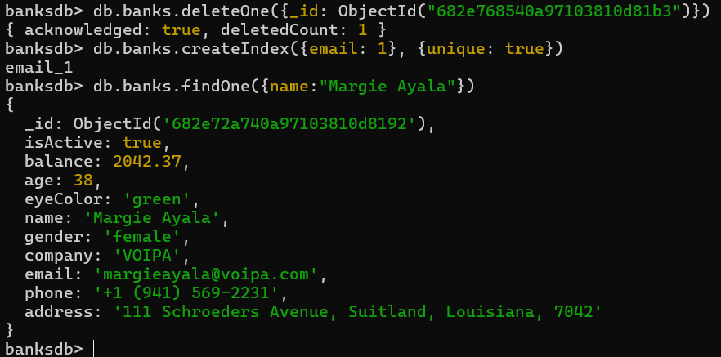
3. Update the final balance after applying one year’s 1% interest rate to the account of all active young female clients whose age below 30. [balance = principal * (1 + rate)] 

4. All inactive middle aged male clients share some common hobbies “reading” and “video games” and they all love “Chinese”, “Korean”, and “French” food, keep this extra information in their profiles. 


5. Some of inactive male clients who have green eyes have lost their passion on Korean food, update their profiles to reflect this change.


Part 2 – MongoDB Queries and Aggregation (json file)
1. List out all cities located in the southwest region of United States.
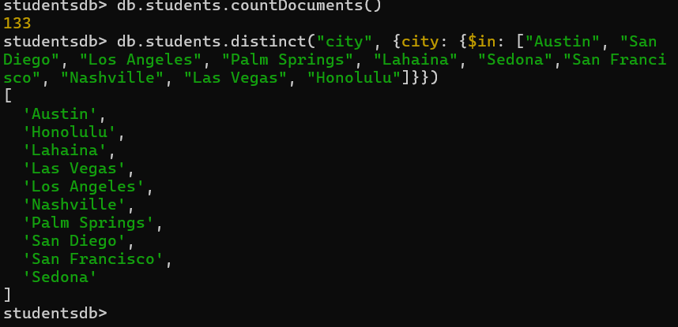
2. Find all adolescents aged under 20, lived in the Southern area of the United States, and have only one hobby. Evaluate the performance of this query, then add an index to improve the performance of this query.
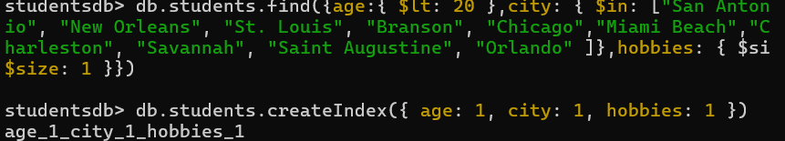
3. How many female students passed all three assessment components in each region? The pass grade is 40 percent.
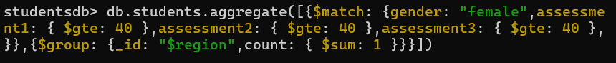
4. How many students have passed all three assessment components in each class of each region?
5. What is the most popular hobby, and which class do students have it?
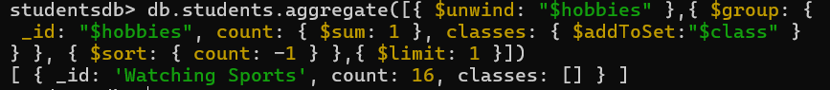
Part 3 – MongoDB Queries and Aggregation (CSV file)
1. There are three groups of patients - patients who have cardiovascular symptom, patients who have neurological symptoms, patients who have sleep-related issues. Create a view for each group of patients. The main cardiovascular symptoms are chest pain, irregular heartbeat, swelling, excessive sweating, nausea/vomiting, and high-blood pressure. The main neurological symptoms are fatigue and weakness, dizziness, persistent cough, anxiety, pain in various parts of the body.
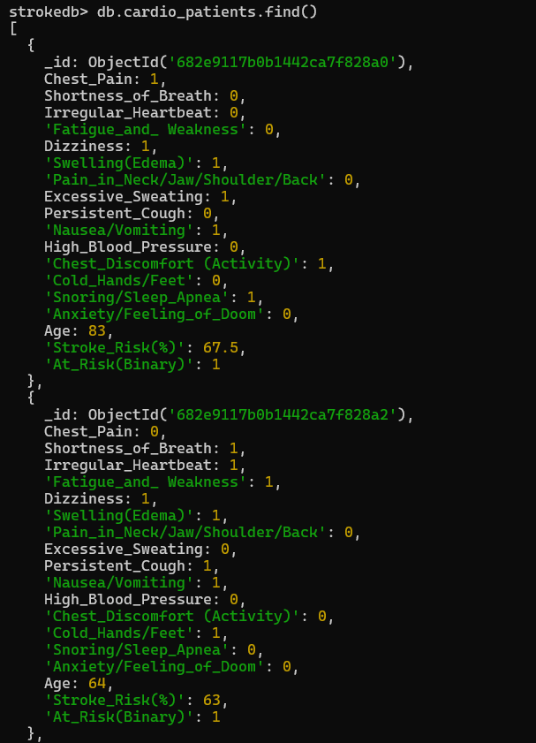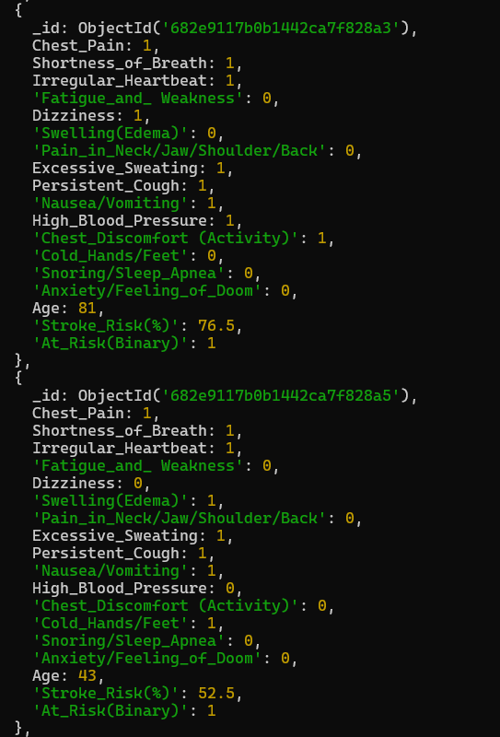
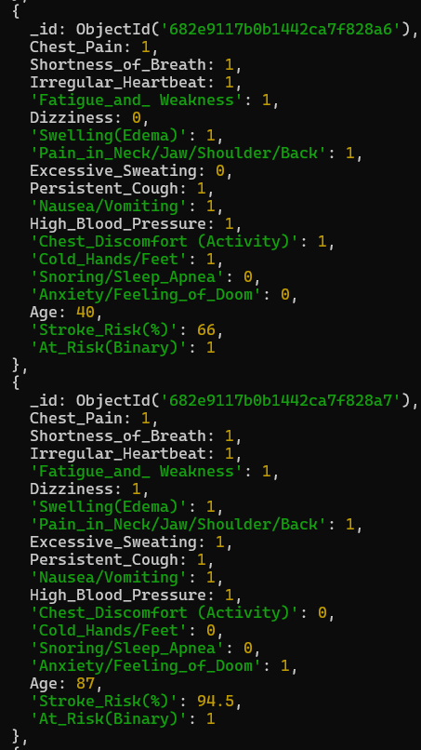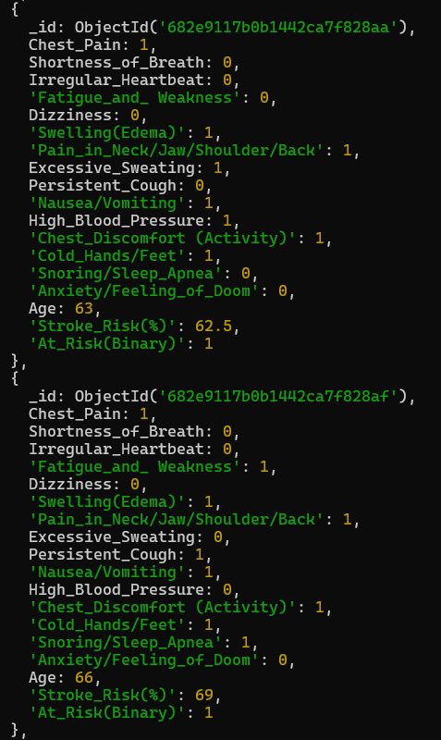


2. Dr. James Smith is a cardiologist, he wants to have an account to directly access the information of patients who suffer from cardiovascular symptoms. He wants to know how many young patients are under 30 years old, who have suffered from chest pain, irregular heartbeats, high blood pressure, and have over 40% chance of getting a stroke.
3. Switch back to the normal user account, how many pensioners aged between 60 and 70 do not have a risk to get a stroke even though they constantly feel dizzy, fatigue, and aches everywhere.
4. Stay as a normal user account, how many patients aged between 40 and 50 have over 45% chance of not getting a stroke when they snore heavily.
5. Stay as a normal user account, find the chances of getting a stroke and the age of a patient when s/he participates some activities without any anxieties, s/he constant feels discomfort in his/her chest, hands/feet are cold, and sometimes short of breath.

